
CASE STUDY REPORT
Medication Adherence Tracker for Elderly Patients

NAME: ALIMA BANU R

REG NO: 192471044

GUIDE NAME: ANITA DAVAMANI K

Table of Contents
Table of Contents 2
1. Executive Summary 3
2. Industry Context 4
3. Problem Statement 6
4. Target Users and Personas 8
5. Objectives 9
6. Proposed Solution Overview 10
7. System Architecture 11
8. Core Features and Modules 13
9. Technology Stack Recommendations 16
10. UX and Accessibility Principles for Elderly Users 17
11. Implementation Roadmap 18
12. Expected Outcomes 19
13. Risk Analysis and Mitigation 20
14. Business Case and Value Proposition 21
15. Illustrative Scenario: A Day in the Life 22
16. Challenges and Limitations 23
17. Conclusion and Recommendations 24
18. Notes on Sources and Data 25

1. Executive Summary
The world's elderly population is growing faster than any other age group, and a large share of this population lives with two or more chronic conditions that require ongoing, often complex, drug regimens. Managing several medications with different dosages, timings, and interaction warnings is difficult even for people with sharp memories; for elderly patients coping with early cognitive decline, visual impairment, or reduced dexterity, it becomes a genuine safety risk. Missed doses, duplicate doses, and incorrect timing are widely cited as contributors to hospital readmissions and avoidable health complications.
This report presents a case study and product concept for a Medication Adherence Tracker built specifically for elderly patients, with a companion caregiver-facing alert system. The concept combines a simplified, elderly-friendly reminder interface with a caregiver dashboard, real-time notifications, and an escalation pathway that alerts family members or professional caregivers when a dose is missed beyond a defined time window. The platform is designed to work whether the patient lives alone, with a partner, or under periodic caregiver visits, and it is intended to integrate with pharmacies and healthcare providers over time.
The remainder of this report walks through the industry context and problem this concept addresses, the market opportunity, the proposed system architecture and feature set, elderly-focused UX principles, a phased implementation roadmap, expected outcomes, and the risks that a team building this platform would need to manage. Illustrative diagrams, wireframes, and charts are included throughout to make the concept concrete; figures describing market size or adherence statistics are labeled as illustrative and are intended to support directional reasoning rather than serve as cited research findings.

2. Industry Context
Population aging is one of the defining demographic shifts of this century. Advances in medicine and public health have extended life expectancy across most regions of the world, and as a result the share of the population aged 65 and older is rising steadily in nearly every country. This shift brings a corresponding rise in the prevalence of chronic conditions such as hypertension, diabetes, cardiovascular disease, arthritis, and early-stage cognitive impairment — conditions that frequently occur together in the same patient and that are typically managed through long-term, multi-drug treatment plans rather than a single course of medicine.
At the same time, family structures and caregiving arrangements have changed. Adult children increasingly live in different cities or countries from their aging parents, and professional in-home caregiving is expensive and not universally accessible. Many elderly patients therefore live independently or with only intermittent supervision, which means that day-to-day responsibility for taking the right medication, in the right dose, at the right time, falls on the patient alone for long stretches of the day.

2.1 Why Medication Management Is Especially Hard for Elderly Patients
- Polypharmacy: it is common for elderly patients to be prescribed five, ten, or more medications simultaneously, each with its own schedule, food restrictions, and interaction warnings.
- Cognitive and sensory decline: memory lapses, mild cognitive impairment, reduced vision, and hearing loss all make it harder to track schedules or read small print on packaging.
- Complex dosing patterns: some medications are taken daily, others weekly, others only as needed, and dosages sometimes change after a doctor's visit — creating a moving target for the patient to track.
- Limited technology familiarity: many mainstream medication apps assume a level of smartphone fluency that not all elderly users have, which discourages adoption even when the underlying idea is sound.
- Fragmented caregiver visibility: family members and professional caregivers typically have no real-time way to know whether a dose was taken unless they are physically present.

2.2 The Shift Toward Remote and Preventive Care
Healthcare systems in many regions are actively trying to shift care away from expensive, reactive hospital treatment and toward preventive, remote, and home-based models. Remote patient monitoring, telehealth consultations, and connected health devices have all seen growing adoption because they let clinicians and caregivers intervene earlier, before a manageable issue becomes an emergency. A medication adherence platform fits naturally into this shift: it is a low-cost, continuous form of monitoring that does not require a clinician's time for routine tracking, and it produces exactly the kind of early-warning signal — a missed dose — that this care model is designed to act on.
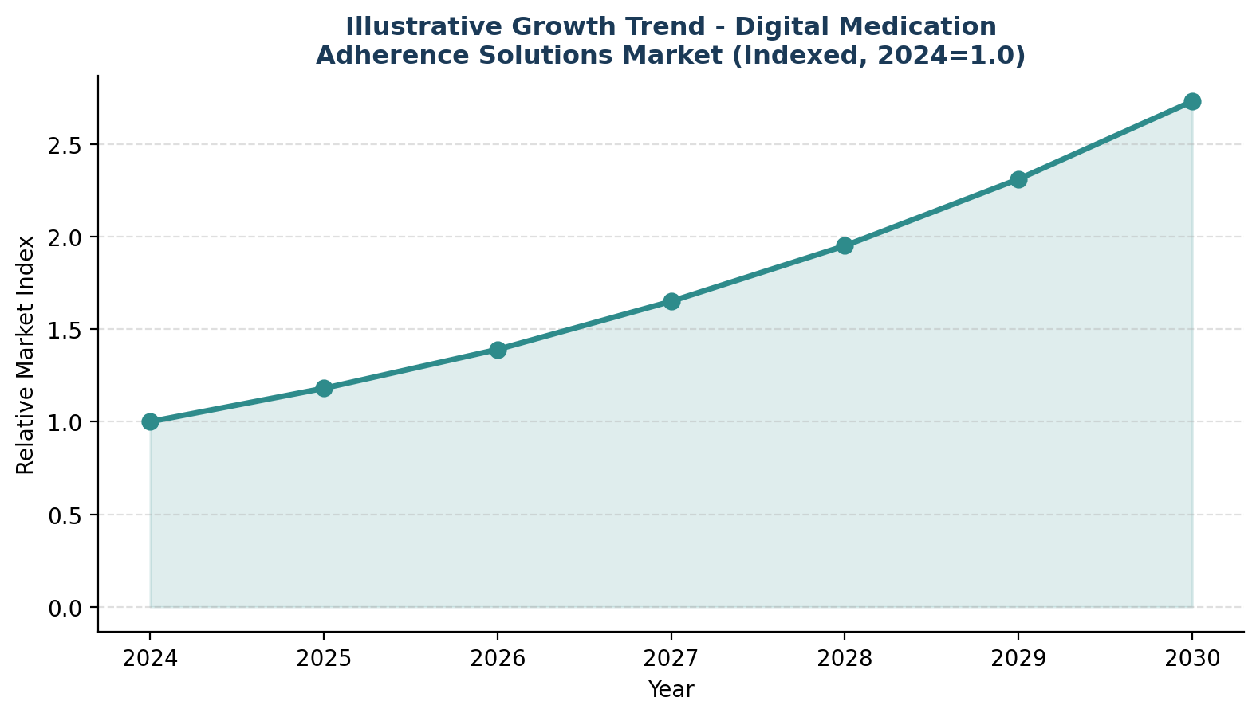
Figure 1. Illustrative growth trend for digital medication adherence solutions, indexed to 2024. Values are directional estimates for discussion purposes, not sourced market data.

3. Problem Statement
Elderly patients managing multiple prescriptions often struggle to remember complex medication schedules, which can lead to missed doses, incorrect dosages, or dangerous drug interactions. Family members and professional caregivers, who frequently do not live with the patient, have no reliable way to monitor whether medications are being taken as prescribed. Traditional tools — paper charts, weekly pill organizers, and sticky-note reminders — are prone to human error and offer no mechanism for remote visibility or alerts when something goes wrong.
When a dose is missed, there is typically a significant delay before anyone else becomes aware of it. For a medication that manages blood pressure, blood sugar, or heart rhythm, that delay can allow a manageable lapse to progress into a health complication that could have been caught and corrected within minutes. Existing medication reminder apps on the market are frequently designed for a general audience and not specifically tuned for elderly usability — dense menus, small touch targets, and reliance on notification-center interactions can be genuinely difficult for someone with limited technical familiarity or reduced dexterity to use reliably.
There is also a structural gap: medication scheduling tools and caregiver communication tools are usually separate. A caregiver might use a messaging app to check in on a parent, and the parent might use a pill organizer or a basic reminder app, but the two are not connected. This makes coordinated care across multiple family members or professional caregivers harder than it needs to be, since no single person has a full, up-to-date picture of adherence.
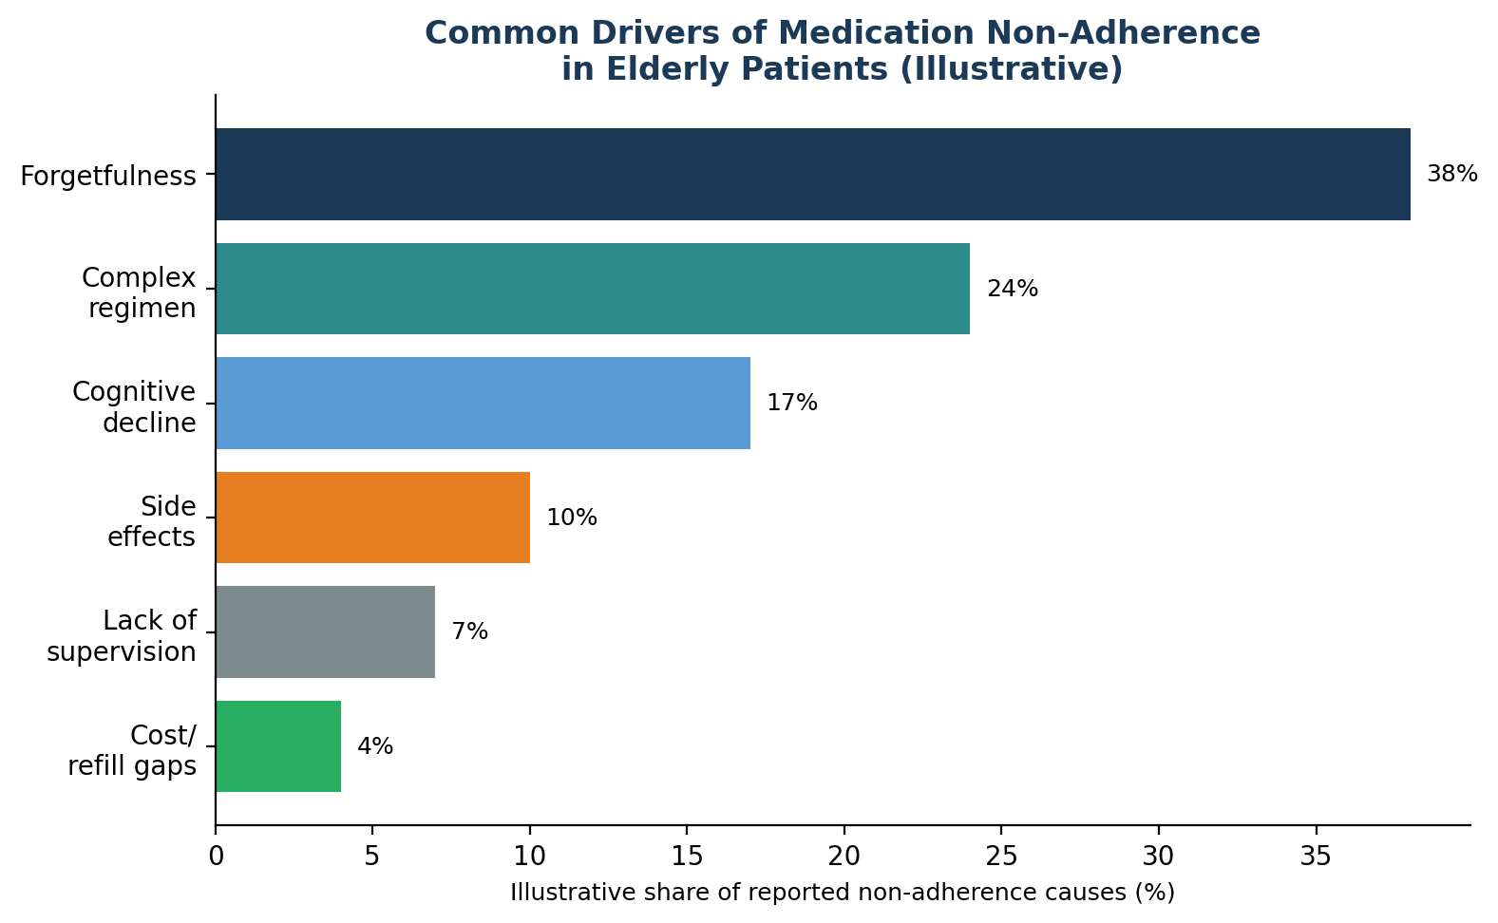
Figure 2. Commonly cited contributors to medication non-adherence in elderly patients. Percentages are illustrative and intended to show relative emphasis, not precise measured shares.
A simple, elderly-friendly medication adherence platform with real-time caregiver alerts is needed to close this gap — reducing missed doses, shortening the time between a missed dose and someone noticing, and giving families and providers a shared, accurate picture of how well a patient's regimen is being followed.

. Target Users and Personas
The platform is designed around two primary user groups whose needs are quite different from one another, and a third group of professional stakeholders who benefit indirectly.

4.1 Primary Persona — The Elderly Patient
Rita, 78, lives alone in her own home following the passing of her husband. She manages high blood pressure, type 2 diabetes, and high cholesterol, and takes four different medications across three times of day. Rita is comfortable with a basic smartphone for calls and photos but finds apps with many menus confusing. She wants to feel independent and does not want a system that makes her feel monitored or judged — she wants reminders that are easy to see, easy to act on, and that quietly reassure her family without requiring her to do anything complicated.

4.2 Primary Persona — The Remote Caregiver
David, 52, is Rita's son and lives two hours away. He calls his mother most evenings but worries about the days he cannot check in. He wants a simple way to know that his mother's medications were taken on time without having to ask her directly every day, and he wants to be notified quickly — not the next morning — if something looks off, so he can call her, contact her doctor, or arrange for a neighbor to check in.

4.3 Secondary Stakeholders
- Primary care physicians and specialists, who benefit from more accurate adherence data during consultations and medication reviews.
- Professional home-care aides and community nurses, who can use the caregiver dashboard as a shared record across shifts.
- Pharmacies, which benefit from earlier, more predictable refill signals and a channel to reach patients directly about supply issues.
- Payers and healthcare systems, which have a financial interest in reducing avoidable hospital readmissions linked to non-adherence.

5. Objectives
The following objectives define the scope of the platform. They are grouped here in a single reference table and expanded individually in Section 7 alongside the corresponding features.
# | Objective
1 | Design a simple, elderly-friendly medication reminder interface with large text, clear icons, and minimal navigation complexity.
2 | Develop a scheduling module allowing caregivers or healthcare providers to input and manage complex multi-drug dosing regimens.
3 | Implement real-time notification and alert systems to remind patients when medications are due.
4 | Build a caregiver dashboard providing visibility into medication adherence history and missed-dose alerts.
5 | Create an escalation mechanism that notifies caregivers immediately if a dose is missed beyond a defined time threshold.
6 | Enable voice-based or simplified confirmation methods for patients to log medication intake with minimal effort.
7 | Integrate refill reminders to alert patients and caregivers when medication supplies are running low.
8 | Ensure data privacy and secure access controls to protect sensitive patient health information.

6. Proposed Solution Overview
The proposed solution is a cloud-connected platform with three coordinated surfaces: a patient-facing mobile application built around large text and voice interaction, a caregiver-facing dashboard for remote monitoring, and a provider/pharmacy-facing portal for schedule management and refill coordination. All three surfaces read from and write to the same underlying adherence record, so a dose confirmed on the patient's phone is reflected on the caregiver's dashboard within seconds, and a schedule change made by a provider updates the patient's reminders automatically.
An optional smart pill dispenser or connected pillbox can extend the concept for patients who struggle with touchscreens altogether, logging doses automatically as compartments are opened. This keeps the core experience usable across a wide range of technical comfort levels — from a patient who is happy to tap a large on-screen button, to one who prefers to simply open a labeled compartment as they always have.
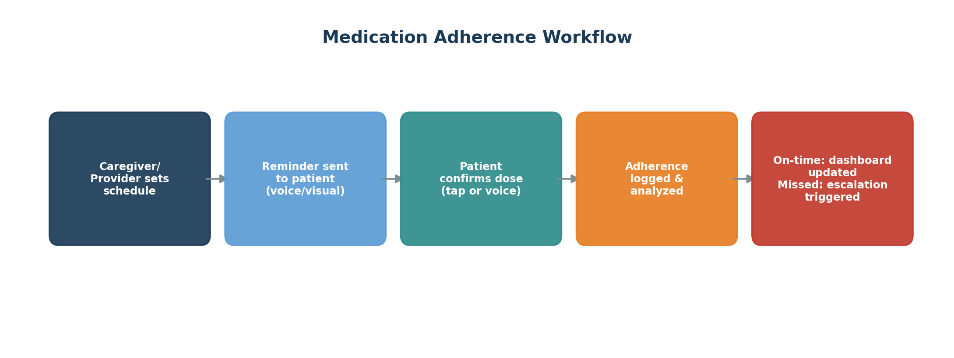
Figure 3. End-to-end medication adherence workflow, from schedule creation through confirmation, logging, and escalation.

7. System Architecture
The architecture is organized around a central cloud-hosted application server that coordinates three supporting services — a scheduling and reminder engine, an adherence analytics engine, and an alert and escalation service — all backed by an encrypted data layer. This separation of concerns allows each service to scale and evolve independently: the reminder engine can be tuned for delivery reliability across SMS, push, and voice-call channels, while the analytics engine focuses on pattern detection (for example, noticing that a patient consistently misses an evening dose) without needing to know how reminders are delivered.
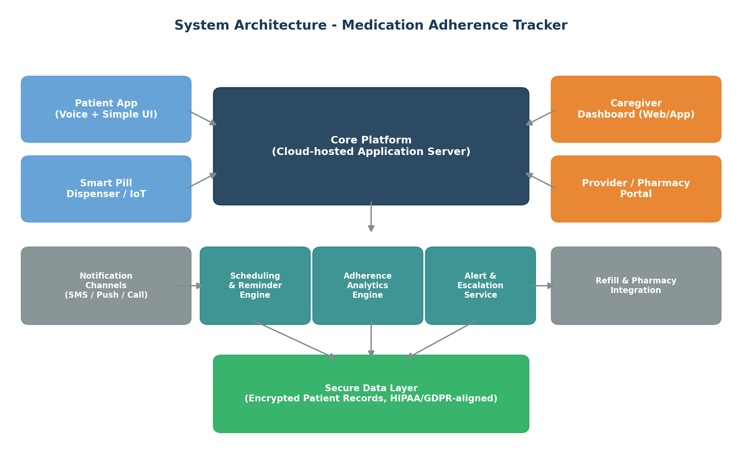
Figure 4. High-level system architecture showing patient, caregiver, and provider touchpoints around a shared core platform.

7.1 Architecture Components
- Patient App — a mobile application optimized for large text, high-contrast icons, and optional voice interaction, paired optionally with a connected pill dispenser.
- Caregiver Dashboard — a web and mobile interface giving family members or professional caregivers a real-time view of adherence, alerts, and refill status.
- Provider / Pharmacy Portal — an interface for clinicians and pharmacists to manage prescriptions, adjust schedules, and receive refill signals.
- Scheduling & Reminder Engine — converts prescription data into a per-patient reminder calendar and triggers notifications at the right time.
- Adherence Analytics Engine — tracks confirmed versus missed doses over time and surfaces trends to the caregiver dashboard and provider portal.
- Alert & Escalation Service — manages the time-based escalation path described in Section 7.2 below when a dose is not confirmed.
- Secure Data Layer — encrypted storage for patient health information, with role-based access control across all three user-facing surfaces.

7.2 Escalation Logic
A core design principle of the platform is that a missed dose should never go unnoticed for long. When a reminder is not confirmed within a short window, the system automatically escalates through a defined sequence of steps rather than relying on a single, easily-missed notification.
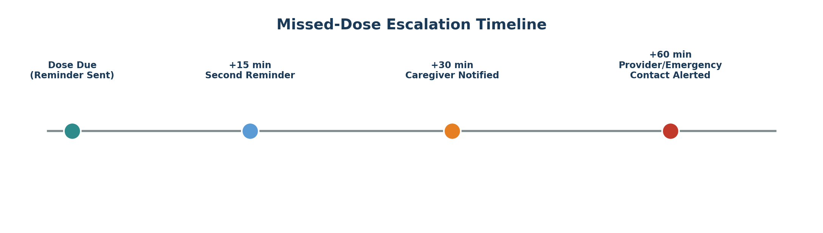
Figure 5. Illustrative missed-dose escalation timeline. Exact thresholds would be configurable per patient and per medication in a production system.

8. Core Features and Modules
This section expands each objective from Section 5 into a concrete feature description.

8.1 Elderly-Friendly Reminder Interface
The patient-facing interface is deliberately minimal. Rather than presenting a full medication list or a calendar view by default, the home screen shows only the next dose that is due, in large text, with a single prominent button to confirm it. Secondary information — the rest of the day's schedule, past history, settings — is available but tucked behind simple, clearly labeled navigation rather than competing for attention on the main screen. Color and iconography follow accessibility best practice: high contrast, no reliance on color alone to convey status, and icons paired with text labels rather than icons alone.
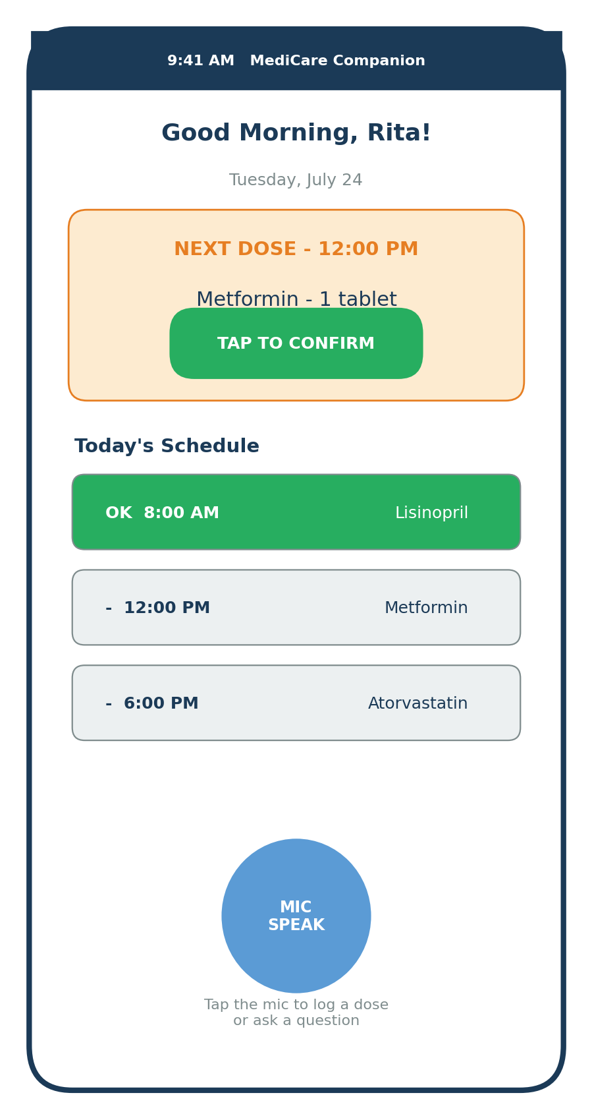
Figure 6. Wireframe of the patient home screen, showing the next-dose card, a simplified daily schedule, and a voice-input option.

8.2 Multi-Drug Scheduling Module
Caregivers or healthcare providers can enter a patient's full regimen — medication name, dosage, frequency, and timing — through a guided setup flow rather than a blank form. The module supports common patterns out of the box (once daily, twice daily, weekly, as-needed) and flags potential scheduling conflicts, such as two medications that should not be taken within the same window. Schedule changes made by a provider after a medication review propagate to the patient's reminders immediately, without requiring the patient or caregiver to re-enter anything.

8.3 Real-Time Notifications
Reminders are delivered through whichever channel best matches the patient's environment and preference — an in-app push notification, a text message, or, for patients who do not reliably check a phone, an automated voice call. Notifications are timed to the prescribed schedule and can include simple context, such as the medication name and a photo of the pill, to reduce the chance of confusion.

8.4 Caregiver Dashboard
The caregiver dashboard consolidates adherence history, missed-dose alerts, and refill status into a single view, and supports multiple patients for caregivers managing more than one family member. A simple weekly view lets a caregiver see at a glance which days went smoothly and which had a missed dose, without needing to dig through a detailed log unless they want to.
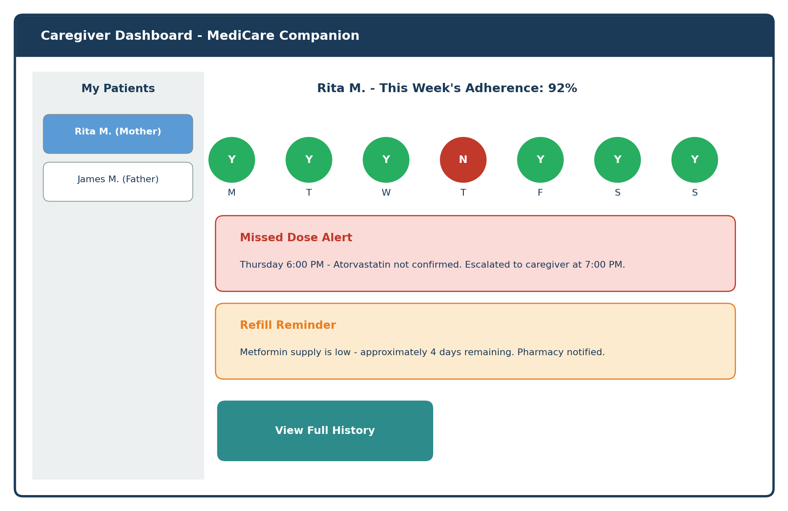
Figure 7. Wireframe of the caregiver dashboard, showing weekly adherence, an active missed-dose alert, and a refill reminder.

8.5 Escalation Mechanism
As outlined in Section 7.2, a missed dose triggers a graduated escalation rather than a single alert. A second, gentler reminder is sent to the patient first, since many missed confirmations are simply a matter of a few minutes' delay rather than a true missed dose. If the dose remains unconfirmed, the caregiver is notified, and if there is still no response, the escalation extends to a secondary contact or, where configured, a healthcare provider. This structure balances timeliness against avoiding alert fatigue from over-notifying caregivers for minor delays.

8.6 Voice-Based and Simplified Confirmation
Recognizing that typing and navigating menus is a barrier for some elderly users, the platform supports voice confirmation as a first-class input method alongside a single large tap-to-confirm button. A patient can simply say a short phrase to log that a dose was taken, or confirm it with one tap if a smart pill dispenser is not in use. Both paths write to the same adherence record used throughout the rest of the system.

8.7 Refill Reminders
The platform tracks remaining medication supply based on confirmed doses and prescription quantities, and proactively alerts both the patient and caregiver when supply is projected to run low — with enough lead time to arrange a refill before doses are missed for lack of medication rather than forgetfulness. Where a pharmacy integration is available, a refill request can be initiated directly from the alert.

8.8 Data Privacy and Security
Because the platform handles sensitive health information, access control is role-based from the ground up: patients, caregivers, and providers each see only the information relevant to their role, and caregiver access is explicitly granted by the patient or their authorized representative rather than assumed by default. Data is encrypted both in transit and at rest, and the architecture is designed to align with recognized healthcare privacy frameworks such as HIPAA in the United States and GDPR in the European Union, with regional compliance requirements assessed for each market the platform operates in.

9. Technology Stack Recommendations
The following stack is a reasonable, illustrative starting point for a platform of this kind; a real implementation team would validate these choices against team expertise, existing infrastructure, and compliance requirements before committing to them.
Layer | Suggested Approach
Patient mobile app | Cross-platform framework (e.g., React Native or Flutter) to reach both iOS and Android with a single accessible codebase, plus native voice-recognition APIs.
Caregiver / provider web app | Responsive web application so caregivers can check in from any device without installing software.
Backend services | Modular, service-oriented backend (e.g., Node.js or Python microservices) separating scheduling, analytics, and alerting as in Section 7.
Notifications | Multi-channel delivery via push notification service, SMS gateway, and automated voice-call provider, with delivery confirmation tracking.
Database | Encrypted relational database for structured health records, supplemented by a time-series store for adherence event logging.
Hosting & compliance | Healthcare-compliant cloud hosting (HIPAA/GDPR-eligible cloud regions) with audit logging and role-based access control.
Integrations | Standards-based interfaces (e.g., HL7 FHIR) for future connection to electronic health records and pharmacy systems.

10. UX and Accessibility Principles for Elderly Users
Designing for elderly users is not simply a matter of enlarging text on an otherwise conventional interface. It requires rethinking interaction patterns from the ground up so that the most important action is always the easiest one to find and complete.
- Progressive disclosure: show only the single next action by default; let users opt into more detail rather than presenting everything at once.
- Large, high-contrast touch targets: buttons sized well above typical mobile guidelines, with strong color contrast that does not rely on subtle shading.
- Consistent placement: primary actions (confirm dose, call for help) always appear in the same location on screen across every use of the app.
- Multiple input modalities: touch, voice, and physical device (smart dispenser) options so the patient can choose whichever feels most natural.
- Forgiving interactions: confirmations are easy to correct if tapped by mistake, and the system avoids punitive language around missed doses.
- Plain language: avoid clinical jargon and app-industry terminology ("sync," "widget") in favor of everyday words.
- Minimal onboarding friction: initial setup is completed by a caregiver or provider on the patient's behalf wherever possible, so the patient's first experience of the app is simply seeing a clear reminder.

11. Implementation Roadmap
A phased rollout allows the team to validate the elderly-facing experience early, before investing heavily in integrations that depend on it. The illustrative roadmap below sequences discovery and UX research ahead of core development, and places pilot testing with real patients before a broader launch.
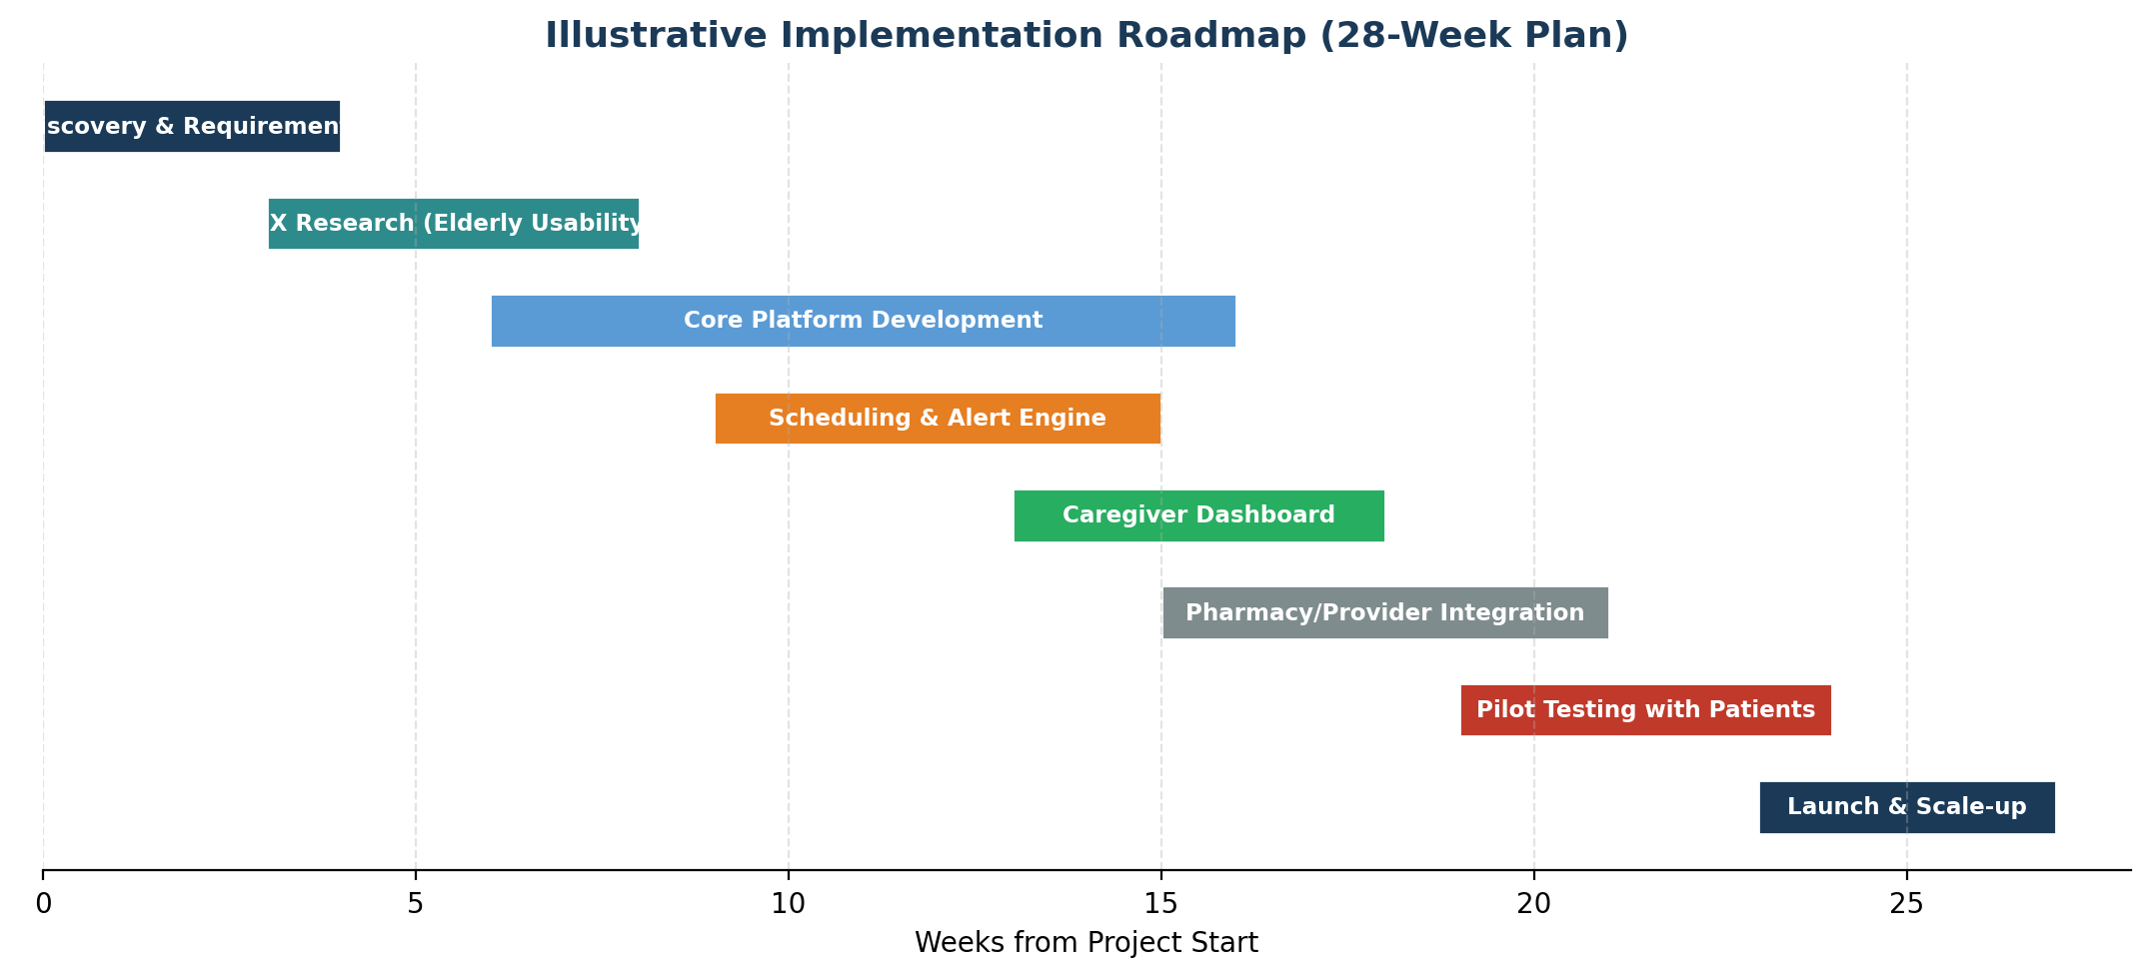
Figure 8. Illustrative 28-week implementation roadmap. Actual timelines would depend on team size, integration scope, and regulatory review requirements in the target market.

11.1 Phase Summary
- Discovery & Requirements — confirm target markets, regulatory requirements, and initial pharmacy/provider integration partners.
- UX Research — usability studies with elderly participants and caregivers to validate the reminder and confirmation flows before heavy engineering investment.
- Core Platform Development — build the scheduling engine, analytics engine, and secure data layer.
- Scheduling & Alert Engine — implement the notification channels and the graduated escalation logic.
- Caregiver Dashboard — build the web/mobile dashboard and multi-patient support for caregivers.
- Pharmacy / Provider Integration — connect refill signals and schedule updates to pharmacy and provider systems.
- Pilot Testing — run a supervised pilot with a small group of patients and caregivers, refining the experience based on real usage.
- Launch & Scale-Up — general availability, followed by expansion of integrations and supported regions.

12. Expected Outcomes
If implemented and adopted successfully, the platform is expected to deliver measurable benefits across patients, caregivers, and the broader healthcare system.
Outcome Area | Expected Benefit
Adherence | Improved medication adherence among elderly patients through timely, accessible reminders.
Health & safety | Reduced risk of missed doses and related health complications through real-time caregiver alerts.
Family wellbeing | Enhanced peace of mind for family members monitoring a patient's care remotely.
Independence | Greater independence for elderly patients, reducing reliance on constant in-person supervision.
Responsiveness | Faster response to adherence issues through immediate, graduated escalation notifications.
System cost | Potential reduction in hospital readmissions and healthcare costs associated with non-adherence.
Coordination | Improved medication management coordination among multiple caregivers or family members.
Scalability | A user-friendly foundation adaptable for future integration with pharmacies and healthcare provider systems.

13. Risk Analysis and Mitigation
A platform of this kind carries real risks that a project team would need to plan for from the outset, particularly given that it touches sensitive health data and is used by a population that may be more vulnerable to being excluded by poor design.
Risk | Potential Impact | Mitigation
Low adoption among elderly patients due to unfamiliarity with technology | Platform fails to achieve its core adherence goal | Early and continuous usability testing with elderly participants; multiple input modalities including voice and physical dispensers.
Alert fatigue among caregivers | Caregivers begin to ignore notifications, undermining the escalation model | Graduated escalation with configurable thresholds; distinguish routine reminders from true missed-dose alerts.
Data privacy or security breach | Loss of sensitive health information; loss of user trust; regulatory penalties | Encryption at rest and in transit, role-based access control, regular security audits, compliance-by-design architecture.
Incorrect or outdated medication data | Wrong reminder times or dosages, risking patient safety | Schedule changes routed through caregivers/providers with confirmation steps; audit trail for all schedule edits.
Dependence on connectivity | Reminders or alerts fail during network outages | Offline-capable reminder scheduling on-device; automatic re-sync and delayed-alert handling once connectivity resumes.
Regulatory complexity across regions | Delays to launch in new markets | Phased regional rollout starting with markets where compliance requirements are well understood.

14. Business Case and Value Proposition
The value proposition of the platform differs by stakeholder, which is one reason a multi-surface design (patient, caregiver, provider) is appropriate rather than a single consumer app. Patients and families are the most direct beneficiaries in terms of safety and peace of mind, but healthcare payers and providers have a financial interest in the outcome as well, since avoidable hospital readmissions linked to medication non-adherence are a recognized and costly problem across many healthcare systems.

14.1 Potential Revenue Models
- Direct-to-consumer subscription for families who want a caregiver dashboard and alerting for a relative.
- Business-to-business licensing to home-care agencies and assisted-living operators managing many patients at once.
- Partnership arrangements with pharmacies, in which refill-driven order volume offsets platform licensing costs.
- Value-based contracts with payers or healthcare systems tied to measurable reductions in adherence-related readmissions.
Any specific pricing or return-on-investment figures would need to be developed against real cost data, regional healthcare economics, and negotiated partnership terms; none are proposed here, since credible numbers require research beyond the scope of this concept report.

15. Illustrative Scenario: A Day in the Life
The following walkthrough illustrates how the platform's pieces work together, using the Rita and David personas introduced in Section 4.
- 8:00 AM — Rita's phone displays a large reminder card for her morning blood pressure medication. She taps the confirm button, and the dashboard updates instantly on David's phone two hours away.
- 12:00 PM — Rita's diabetes medication reminder appears. She is out in the garden and misses the first notification.
- 12:15 PM — A gentle second reminder is sent, per the escalation logic in Section 7.2. Rita comes inside, sees the reminder, and confirms the dose by tapping the button.
- 6:00 PM — Rita's cholesterol medication reminder is sent, but this time it goes unconfirmed for 30 minutes.
- 6:30 PM — David receives a caregiver alert on his dashboard and phone. He calls his mother, who had simply lost track of time, and reminds her to take the dose — which she then confirms.
- 6:45 PM — The refill module flags that Rita's metformin supply will run out in four days, and both Rita and David receive a low-supply notice, with enough lead time to request a refill before it becomes a missed-dose problem.
This scenario highlights the platform's core value: most days pass with simple, low-friction confirmations, but on the day something does go off track, the right person finds out quickly enough to act.

16. Challenges and Limitations
It is worth being direct about the limitations of a concept like this one, since acknowledging them is part of building a realistic implementation plan rather than an idealized one.
- No reminder system can fully substitute for a patient's own engagement; some patients may resist using any tracking tool, particularly if they feel it undermines their independence.
- Voice recognition accuracy can vary with accents, hearing-related speech changes, or background noise, and needs realistic testing with the target population rather than a general-purpose voice assistant benchmark.
- A smart pill dispenser adds cost and a physical device to manage, which may not suit every household or every medication type (for example, liquid medications or injections).
- Escalation to a caregiver assumes an available, responsive caregiver; patients without an engaged support network gain less from this specific safety net, and may need a provider-level escalation option instead.
- Any integration with pharmacies or electronic health records depends on partner willingness and regional data-sharing regulations, which can slow rollout in some markets.

17. Conclusion and Recommendations
The case for a dedicated, elderly-friendly medication adherence platform rests on a straightforward observation: the tools most elderly patients currently rely on — paper charts, weekly pillboxes, and occasional phone check-ins — were never designed to catch a missed dose quickly or to keep a remote caregiver genuinely informed. A platform that combines a simple, forgiving patient interface with a real-time caregiver dashboard and a graduated escalation path addresses that gap directly, without requiring the patient to change how independently they live.
The recommended next step is not a full build, but a focused discovery and usability research phase, as reflected in the roadmap in Section 11. Validating the reminder and confirmation experience directly with elderly participants — before committing engineering resources to the wider platform — is the highest-leverage way to reduce the single biggest risk identified in this report: that a well-intentioned tool goes unused because it was not truly designed around the people it is meant to serve.

18. Notes on Sources and Data
This report is a concept and case-study document rather than a cited research paper. Statements about the general challenges of population aging, polypharmacy, and remote caregiving reflect widely recognized, publicly discussed trends in healthcare and aging-in-place literature. Charts and figures describing market growth, non-adherence causes, and implementation timelines are explicitly labeled as illustrative throughout the report and are intended to support reasoning about the concept, not to represent findings from a specific study. A production-ready business case or investment proposal built from this concept would require dedicated primary research, market sizing, and clinical evidence review before any figures were presented as factual claims.

